Module Name: Login Page
Test Case ID: 183
Webpage URL: https://practicetestautomation.com/

● Scenario ID: 4a
Scenario: Review Requirement Document
Test Steps:
- Open Login Page
- Valid Username
- Valid Password
- Login

Screenshots: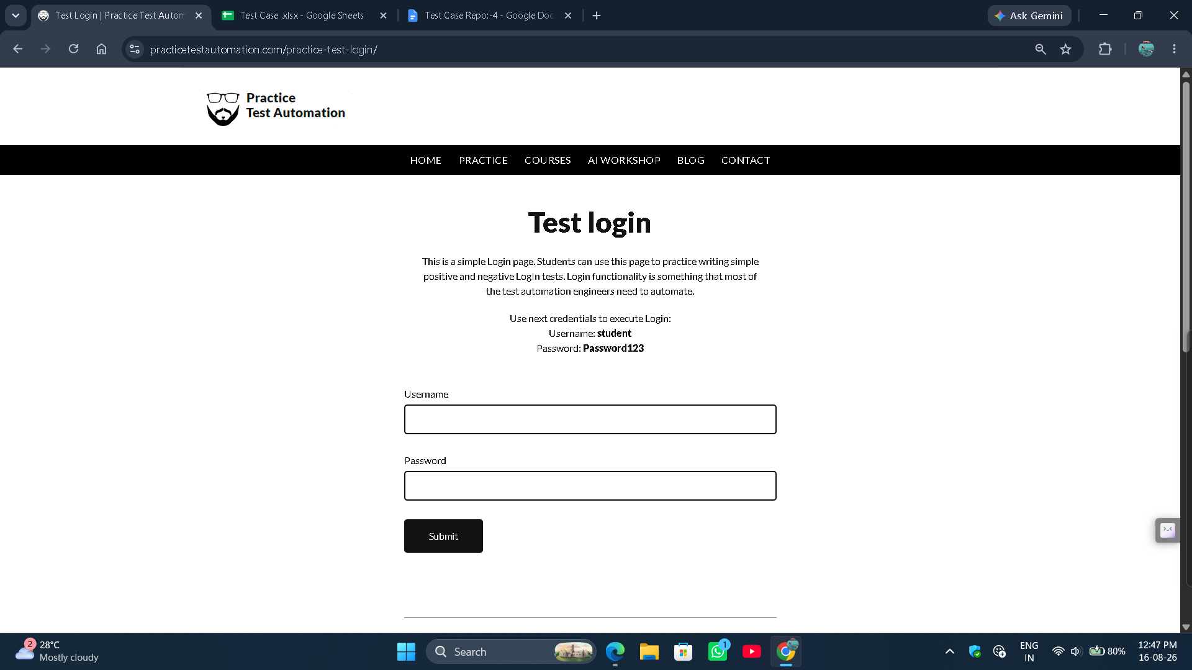

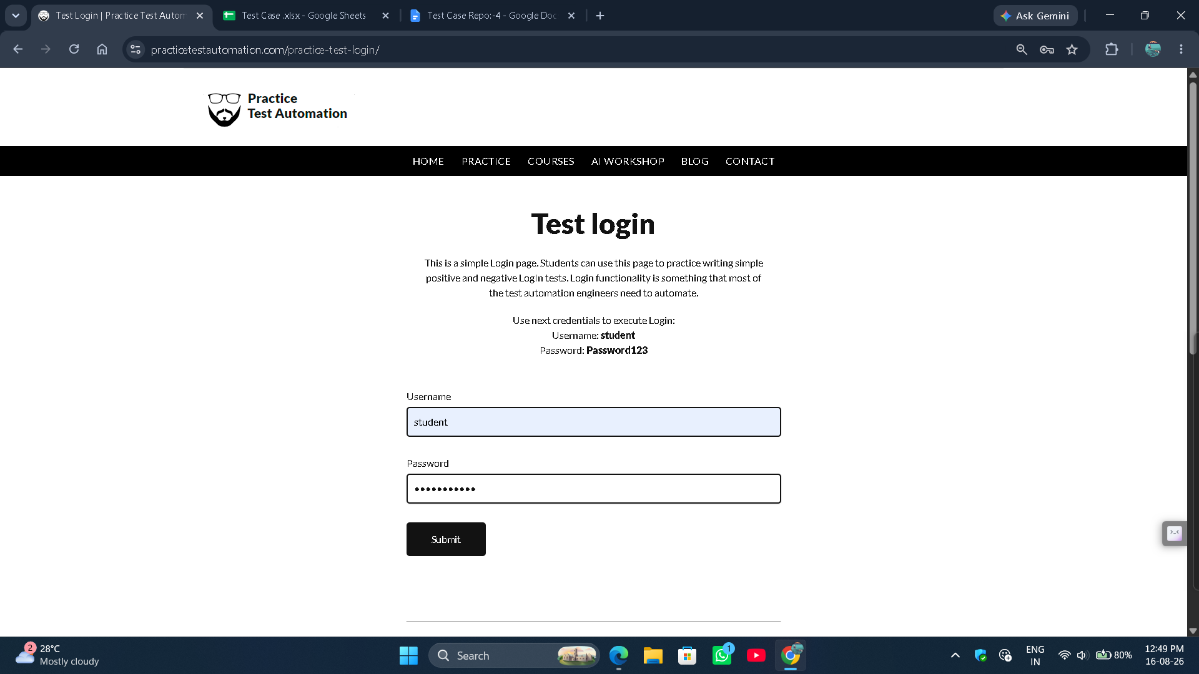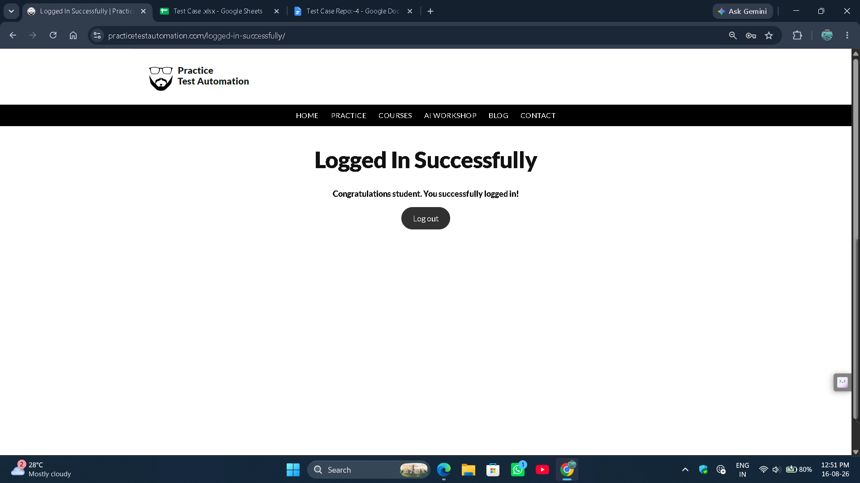

● Scenario ID: 4b
Scenario: Login with Invalid Username
Test Steps:
- Open Login Page.
- Invalid Username
- Valid Password
- Click Login

Screenshots: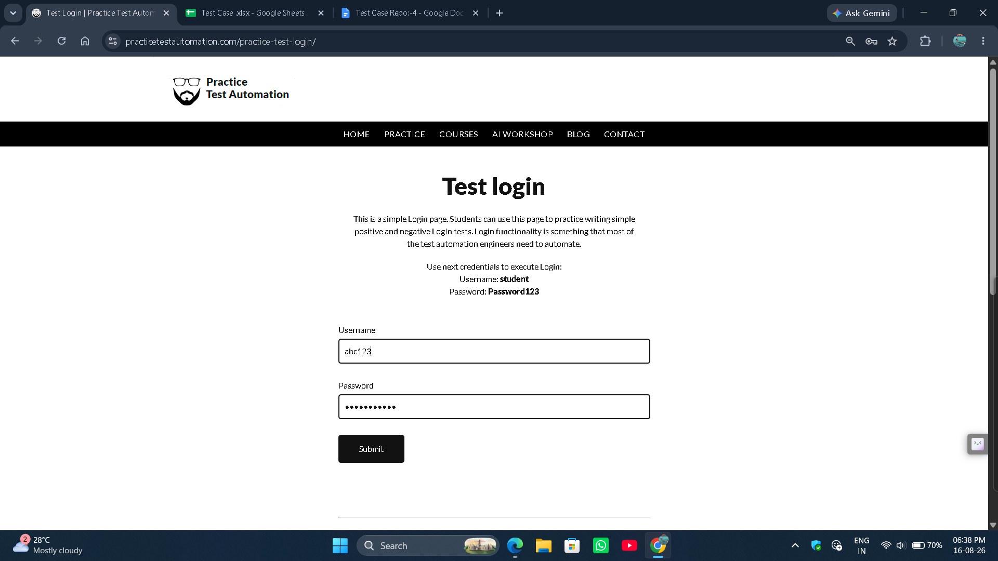

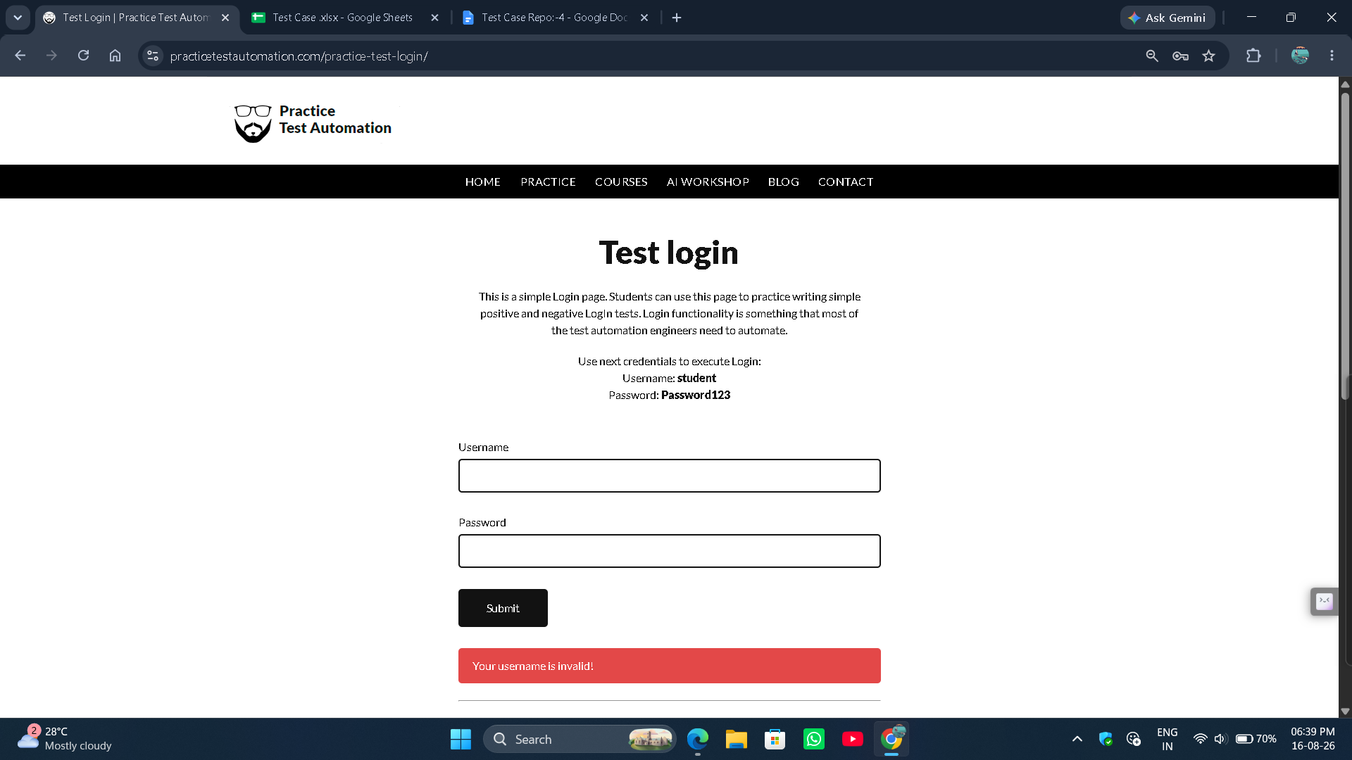

● Scenario ID: 4c
Scenario: Login with Invalid Password
Test Steps:
1.Open Login Page
2. Valid Username
3. Invalid Password
4. Login

Screenshots: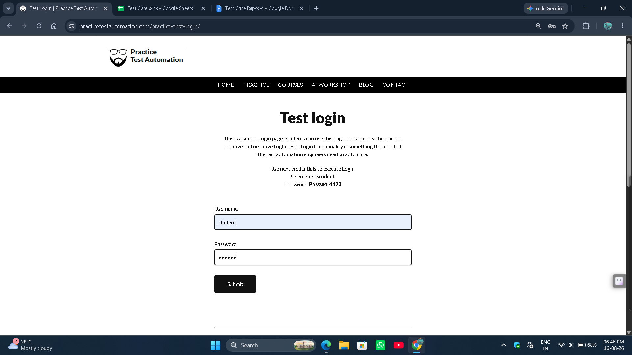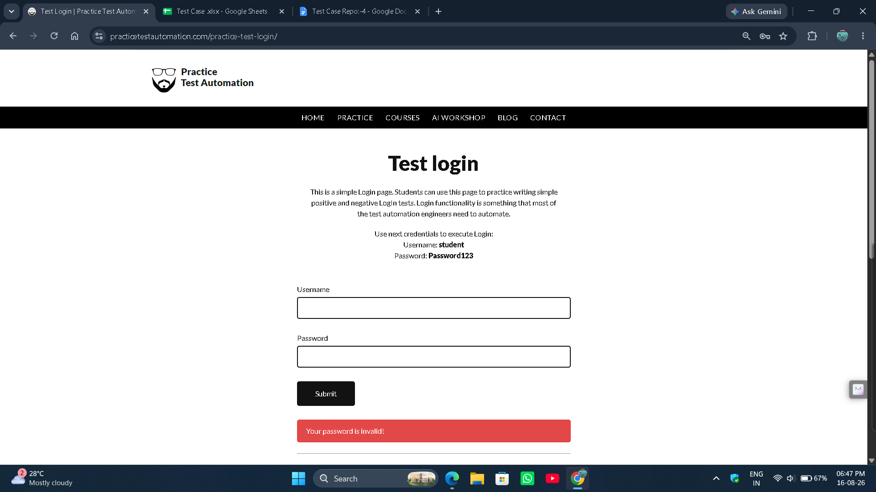

● Scenario ID: 4d
Scenario: Login with Empty Username
Test Steps:
- Open Login Page
2. Blank Username
3. Valid Password
4. Login

Screenshots: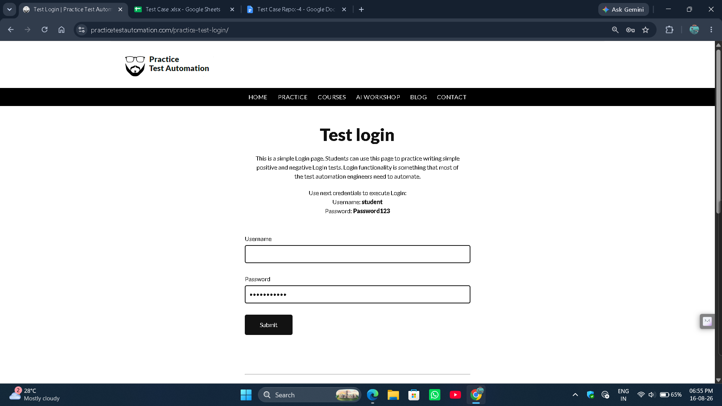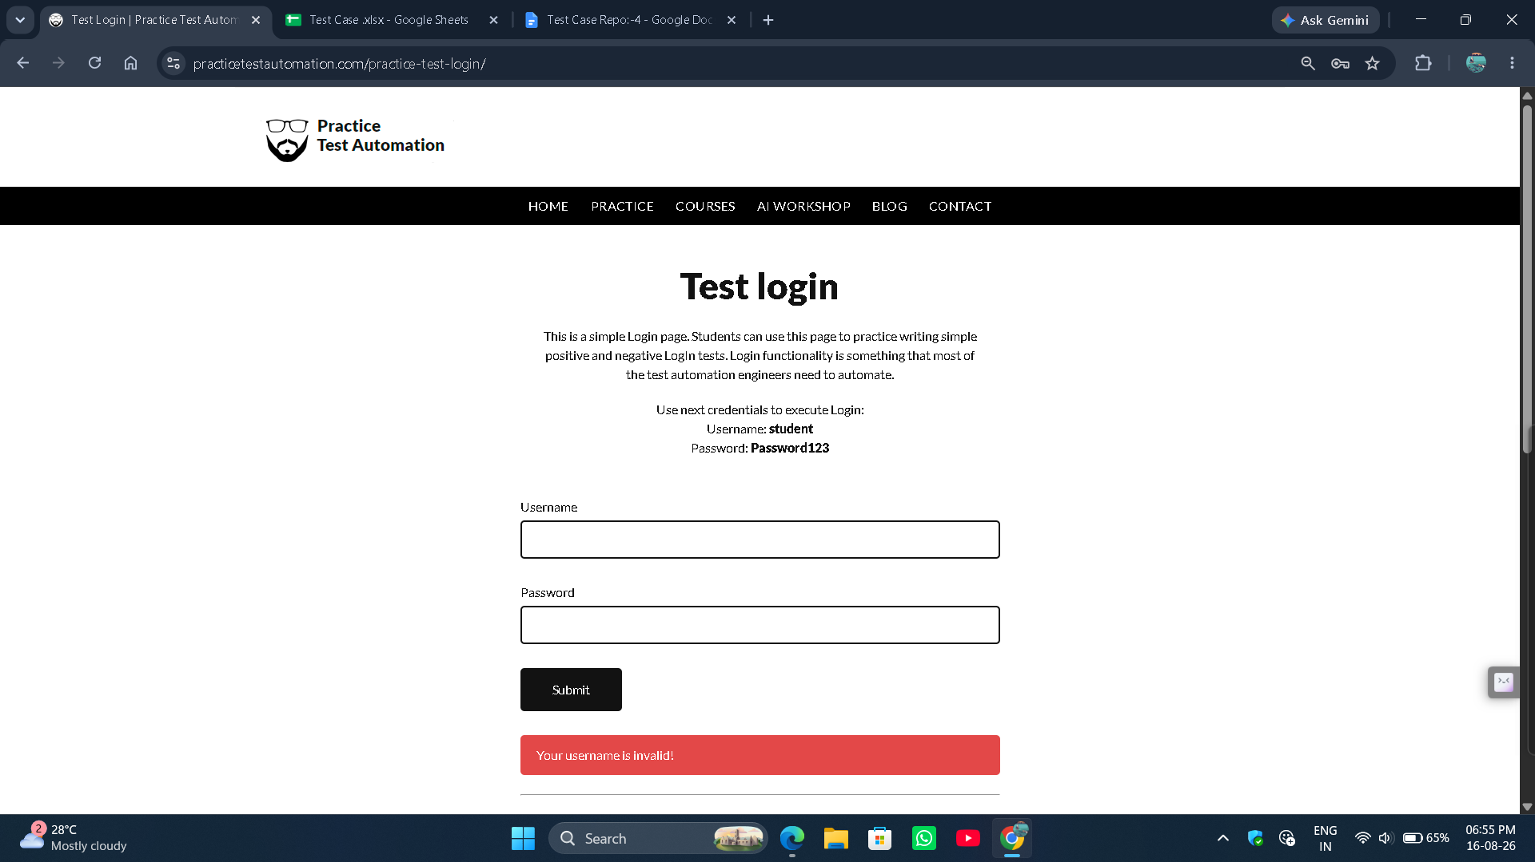

● Scenario ID: 4e
Scenario: Login with Empty Password
Test Steps:
- Open Login Page
- Valid Username
- Valid Password
- Login

Screenshots: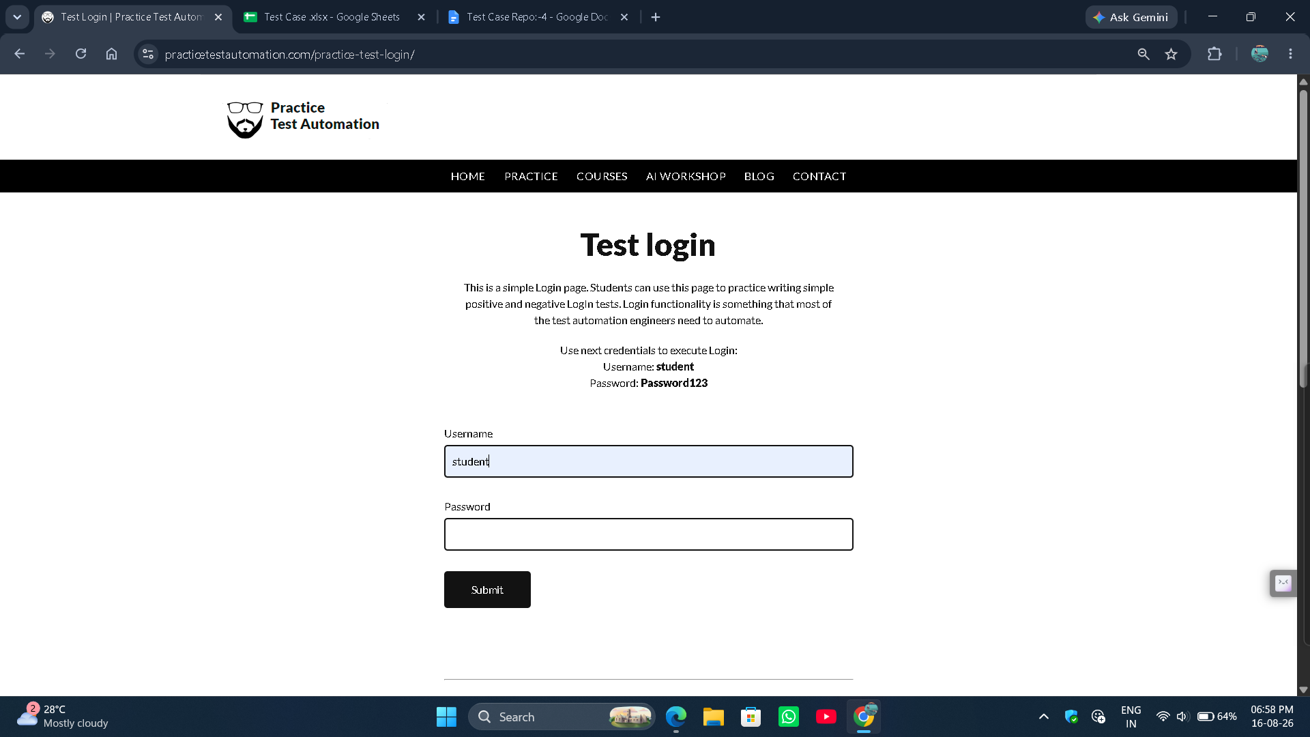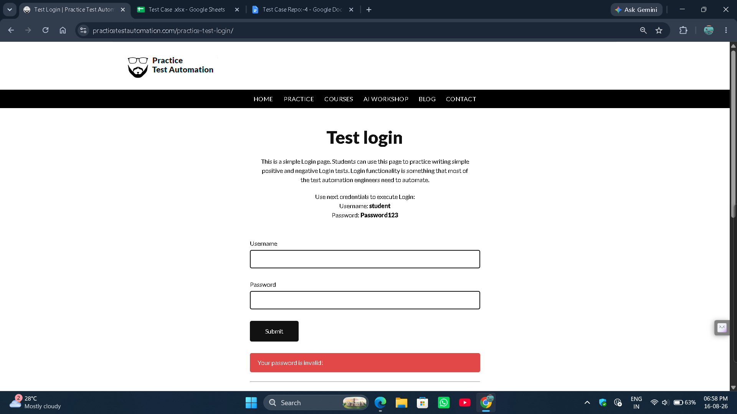

● Scenario ID: 4f
Scenario: Login with Empty Username/Password
Test Steps:
- Open Login Page
- Valid Username
- Valid Password
- Login
Screenshots: